NEW 01 | 紧凑型全不锈钢旋转升降拖猪车  Compact Stainless-Steel Rotating & Lifting Pig Trailer

产品介绍 PRODUCT OVERVIEW  采用全不锈钢车身与紧凑型底盘，集电动行走、提升、仰俯和旋转定位于一体。窄车身便于在猪舍通道内转向和贴近栏位，倾斜滑板可降低装载高度，减少人工搬运强度；平整不锈钢表面便于冲洗与日常消毒。  A compact all-stainless-steel handling unit combining powered travel, lifting and tilt functions with rotary positioning. Its narrow chassis is designed for maneuvering through pig-house aisles and approaching pens, while the inclined loading deck reduces manual handling. Smooth stainless surfaces support efficient washing and routine disinfection.
  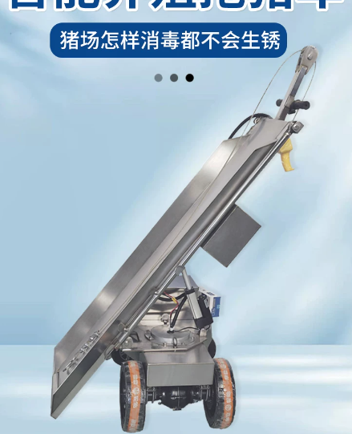 | 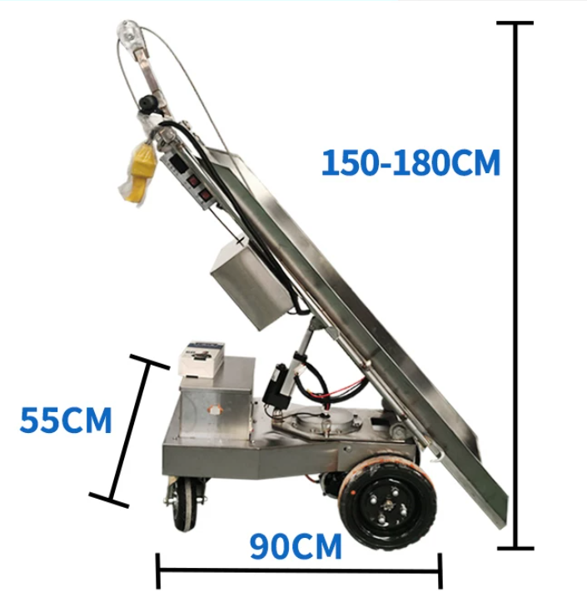
  整车材质  Material | 全304不锈钢结构  All-304 stainless-steel construction
  外形尺寸  Dimensions | 长约90cm，宽约55cm，工作高度约150–180cm  Approx. 90 cm L × 55 cm W; working height approx. 150–180 cm
  结构特点  Structure | 紧凑底盘、倾斜滑板、旋转定位机构  Compact chassis, inclined deck and rotary positioning mechanism
  适用场景  Applications | 猪舍通道、栏位转运、病死猪无害化转运  Pig-house aisles, pen-side transfer and mortality handling
  拖猪方式  Loading directions | 左侧、右侧、正前方均可对接  Can be approached from the left, right, or straight ahead.
  产品特点  Key functions | 电动行走、电动提升、电动仰俯、轻便旋转  Powered travel, powered lifting, powered tilt, and easy manual rotation.
  电池箱规格  Battery box | 201不锈钢电池箱，约33.5×19×24cm，底板厚1mm  201 stainless-steel battery box, approx. 33.5 × 19 × 24 cm, with a 1 mm base plate.
  钢丝绳规格  Wire rope | 304不锈钢，长10m，直径6mm  304 stainless-steel wire rope, 10 m long, Ø6 mm.
  前轮规格  Front wheels | 400-6充气轮，直径约330mm  400-6 pneumatic wheels, approx. Ø330 mm.
  后轮规格  Rear wheel | 350-4实心万向轮，直径约250mm  350-4 solid swivel caster, approx. Ø250 mm.
  电池规格  Battery | 4块12V 20Ah全新铅酸蓄电池  Four new 12 V 20 Ah lead-acid batteries.
  充电器  Charger | 48V 20A充电器  48 V 20 A charger.
  持续工作时间  Operating time | 持续使用6小时以上  More than 6 hours of continuous operation.
  行走系统  Travel system | 最大功率1000W，防水等级IP54  Maximum power: 1000 W; ingress protection: IP54.
  提升系统  Lifting system | 功率1000W，垂直拉力800kg，防水等级IP67  Power: 1000 W; vertical pulling force: 800 kgf; ingress protection: IP67.
  仰俯系统  Tilting system | 48V电动推杆，最大推力700kg，防水等级IP56  48 V linear actuator; maximum thrust: 700 kgf; ingress protection: IP56.
  控制系统  Control system | 急停、电源、提升、仰俯开关及电量显示表  Emergency stop, master power, lift and tilt switches, plus a battery level indicator.
  操控方式  Driving controls | 左侧刹车把手控制旋转定位销；右侧转把控制行走  The left brake lever operates the rotary locking pin; the right twist throttle controls travel.
  行走速度  Travel speed | 前进最高5km/h，倒车最高3km/h  Forward speed up to 5 km/h; reverse speed up to 3 km/h.
  整车防护  Overall protection | 整车IP54，可防雨淋和喷洒消毒液，禁止浸泡  Overall IP54 protection. Suitable for rain exposure and disinfectant spraying; do not immerse.

NEW 02 | 护栏式全不锈钢旋转升降拖猪车  Guardrail Stainless-Steel Rotating & Lifting Pig Trailer

产品介绍 PRODUCT OVERVIEW  在全不锈钢旋转升降底盘基础上增加双侧护栏和宽幅承载滑板，为装载、提升及移动过程提供更清晰的导向与侧向防护。大直径驱动轮配合前端万向轮，兼顾承载稳定性与转向灵活性，适用于规模化猪场的日常转运及清洁消毒环境。  Built on an all-stainless-steel rotating and lifting chassis, this version adds full-length side guardrails and a wide loading deck for improved guidance and lateral containment during loading, lifting and transport. Large drive wheels and a front swivel caster balance stability with maneuverability, making the unit suitable for routine transfer work on commercial pig farms.
  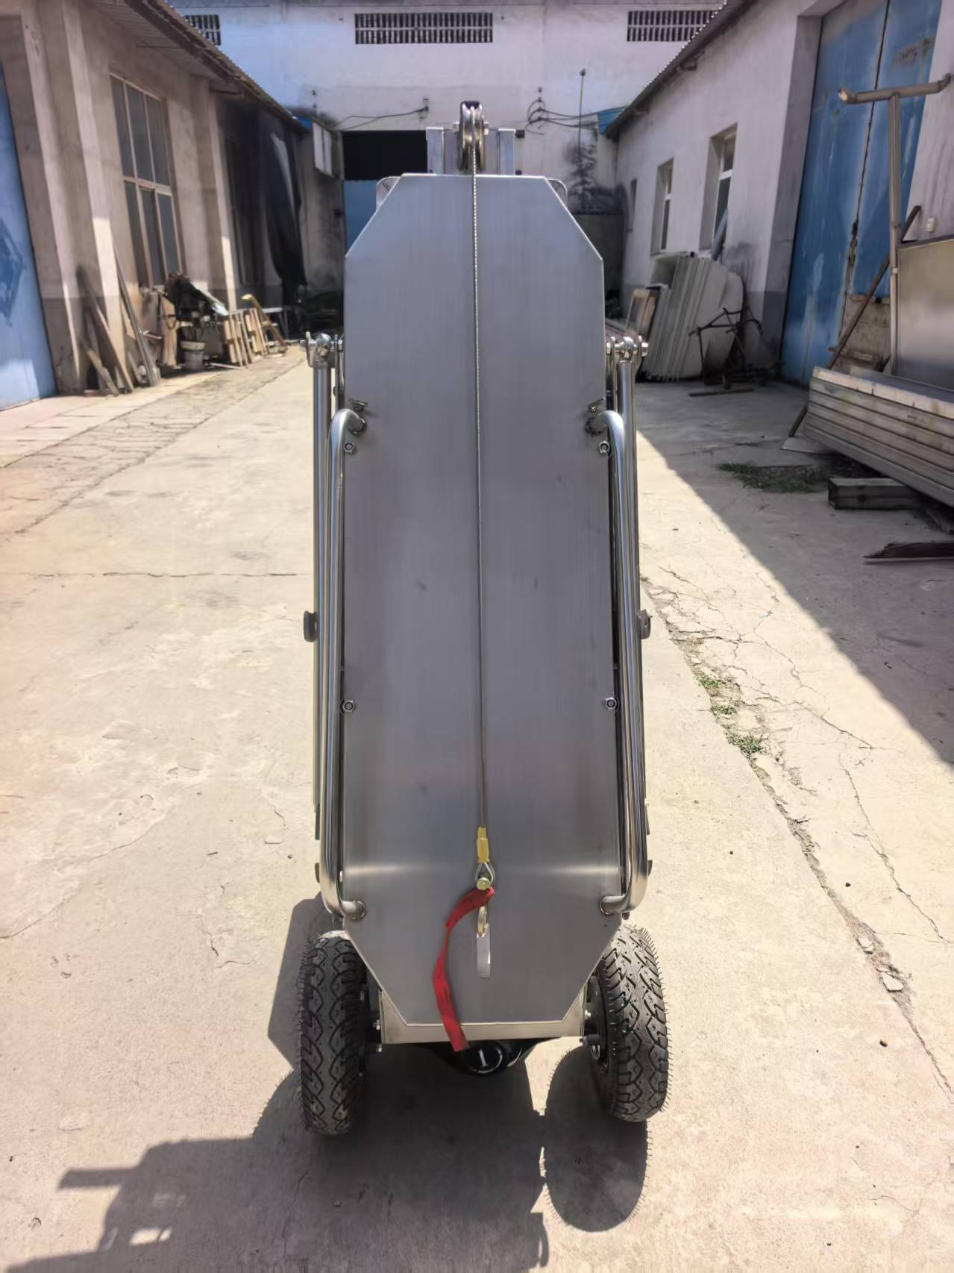 | 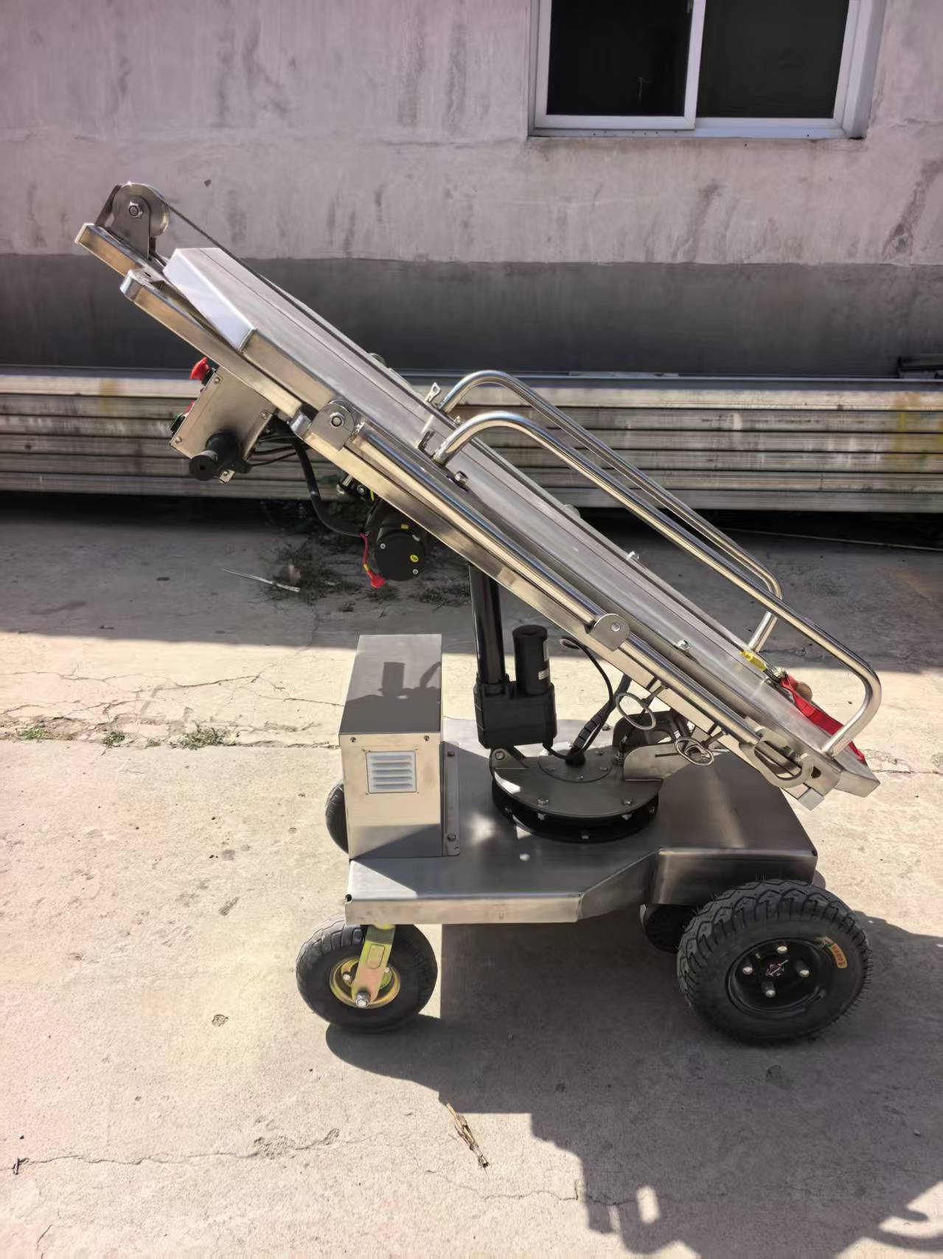
  整车材质  Material | 全304不锈钢结构  All-304 stainless-steel construction
  外形尺寸  Dimensions | 以最终生产图纸或订单确认为准  To be confirmed by the final production drawing or order
  结构特点  Structure | 宽幅滑板、双侧护栏、旋转升降底盘  Wide deck, dual side guardrails and rotating lifting chassis
  适用场景  Applications | 规模猪场、栏位转运、病死猪无害化转运  Commercial pig farms, pen-side transfer and mortality handling
  拖猪方式  Loading directions | 左侧、右侧、正前方均可对接  Can be approached from the left, right, or straight ahead.
  产品特点  Key functions | 电动行走、电动提升、电动仰俯、轻便旋转  Powered travel, powered lifting, powered tilt, and easy manual rotation.
  电池箱规格  Battery box | 201不锈钢电池箱，约33.5×19×24cm，底板厚1mm  201 stainless-steel battery box, approx. 33.5 × 19 × 24 cm, with a 1 mm base plate.
  钢丝绳规格  Wire rope | 304不锈钢，长10m，直径6mm  304 stainless-steel wire rope, 10 m long, Ø6 mm.
  前轮规格  Front wheels | 400-6充气轮，直径约330mm  400-6 pneumatic wheels, approx. Ø330 mm.
  后轮规格  Rear wheel | 350-4实心万向轮，直径约250mm  350-4 solid swivel caster, approx. Ø250 mm.
  电池规格  Battery | 4块12V 20Ah全新铅酸蓄电池  Four new 12 V 20 Ah lead-acid batteries.
  充电器  Charger | 48V 20A充电器  48 V 20 A charger.
  持续工作时间  Operating time | 持续使用6小时以上  More than 6 hours of continuous operation.
  行走系统  Travel system | 最大功率1000W，防水等级IP54  Maximum power: 1000 W; ingress protection: IP54.
  提升系统  Lifting system | 功率1000W，垂直拉力800kg，防水等级IP67  Power: 1000 W; vertical pulling force: 800 kgf; ingress protection: IP67.
  仰俯系统  Tilting system | 48V电动推杆，最大推力700kg，防水等级IP56  48 V linear actuator; maximum thrust: 700 kgf; ingress protection: IP56.
  控制系统  Control system | 急停、电源、提升、仰俯开关及电量显示表  Emergency stop, master power, lift and tilt switches, plus a battery level indicator.
  操控方式  Driving controls | 左侧刹车把手控制旋转定位销；右侧转把控制行走  The left brake lever operates the rotary locking pin; the right twist throttle controls travel.
  行走速度  Travel speed | 前进最高5km/h，倒车最高3km/h  Forward speed up to 5 km/h; reverse speed up to 3 km/h.
  整车防护  Overall protection | 整车IP54，可防雨淋和喷洒消毒液，禁止浸泡  Overall IP54 protection. Suitable for rain exposure and disinfectant spraying; do not immerse.

